Hydrosphere Study Guide Name___________________________
1) _____ of the Earth’s hydrosphere is fresh water.

2) List all the processes described in your notes that participate in the water cycle. Briefly describe what happens in each.

3) Place letter A or B next to each of the descriptions that apply to either A or B.
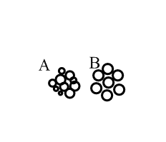
_____ a. well sorted _____ b. high permeability
_____ c. represents silt/clay _____ d. poorly sorted
_____ e. low porosity _____ f. represents sand/gravel
_____ g. low permeability _____ h. high porosity
i. Which has the highest mass, a piece of gravel, silt, clay, or shale?
4) Label the following picture with these vocabulary terms: zone of saturation, water table, aquiclude, zone of aeration.
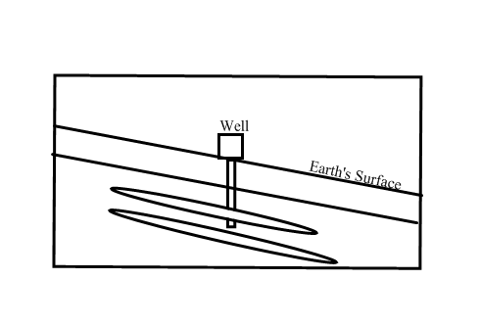
a. Which zone will have pores that contain water?
b. What type of aquifer is the well tapped into?
c. Groundwater will be flowing towards what direction of your paper (right or left)? Why?
d. How will the water table change if a drought occurs?
e. How will the water table change if it rains for a week?
5) Define drawdown. Explain how recharge is related to drawdown.
6) 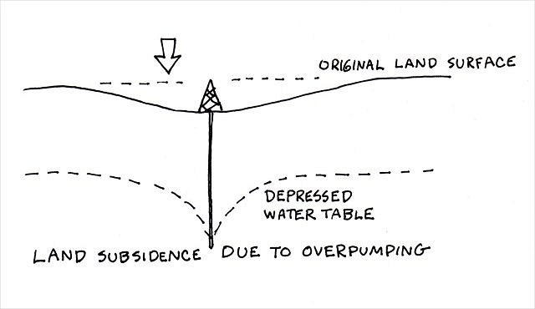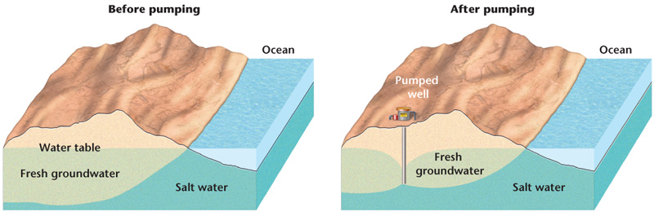
a. What specific threat is illustrated in the image on the left?
b. What specific threat is illustrated in the image on the right?

7) Three men are fishing in a stream. The man fishing 10 miles from the delta of the river pours Coke Zero into the river. The man fishing 20 miles from the delta of the river pours Diet A&W Root Beer in the river. The man fishing 30 miles from the delta of the river pours Crystal Light Peach Tea into the river.
a. What pollutants will a swimmer be in 15 miles from the delta of the river?
b. How about a swimmer that is 5 miles from the delta of the river?
c. Since a specific area of contamination can be located, what type of pollution is this an example of?
d. Assume that Yoo Hoo chocolate drink contaminates water near the delta and its source is unknown. What type of pollution is this an example of?
8) Three pieces of sediment are in a river. Sediment A has a mass of 15 grams. Sediment B has a mass of 0.01 gram. Sediment C has a mass of 1 gram.
a. Sediment A would most likely be characterized as what type of stream load?

b. Sediment B would most likely be characterized as what type of stream load?

c. Sediment C would most likely be characterized as what type of stream load?

d. Which of the following sediments, A or C, will deposit the furthest away from the ocean?

e. What will happen to the speed of all sediments as they move closer to the mouth of the river?

9) My four friends and I like to hike. We reached the bottom of a mountain once and found a large area of sediment deposited near a stream. What is this sediment deposit called and why does it form?

10) Match the appropriate vocabulary term with the definition.
_____ 1) ground along the side of a stream a. bed load b. gradient
_____ 2) ground along which stream flows c. solution d. river
_____ 3) slope of a river e. channel f. tributaries
_____ 4) streams that flow into other streams, making them larger g. suspension h. base level
_____ 5) particles small enough to be held aloft in water i. banks j. meander
_____ 6) particles dissolved in water
_____ 7) curve

11) Place the following terms in the appropriate column: higher salinity, driven by wind, driven by density, lower salinity, more dense, poles, low amount of nutrients, equator, less dense, high amount of nutrients
Surface Currents Deep Water Currents

12) Why does sand increase temperature at a faster rate than water?

